

**NAME** :  *KASHIF MAJID DAR*

**BRANCH**:  *CS B-1*

**BATCH**: *2019-23*

**PRN:**  *19070122084*

**Programming and Problem Solving Lab**

**Assignment 3**

# Write an algorithm and Python program that reads three numbers and prints the value of the largest number?

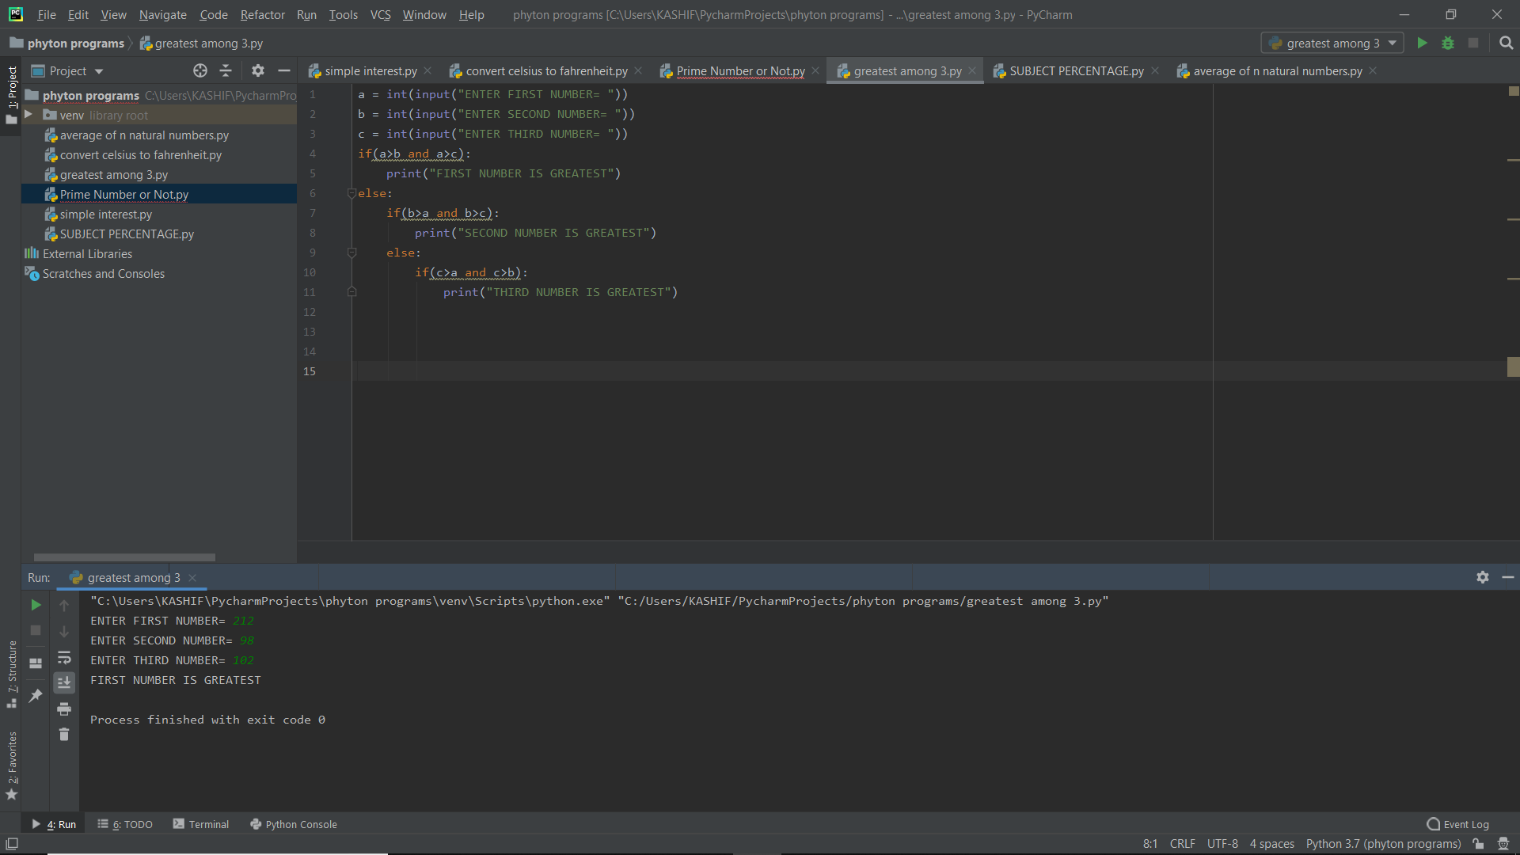

1. Python Program to Take the Temperature in Celcius and Covert it to Farenheit?

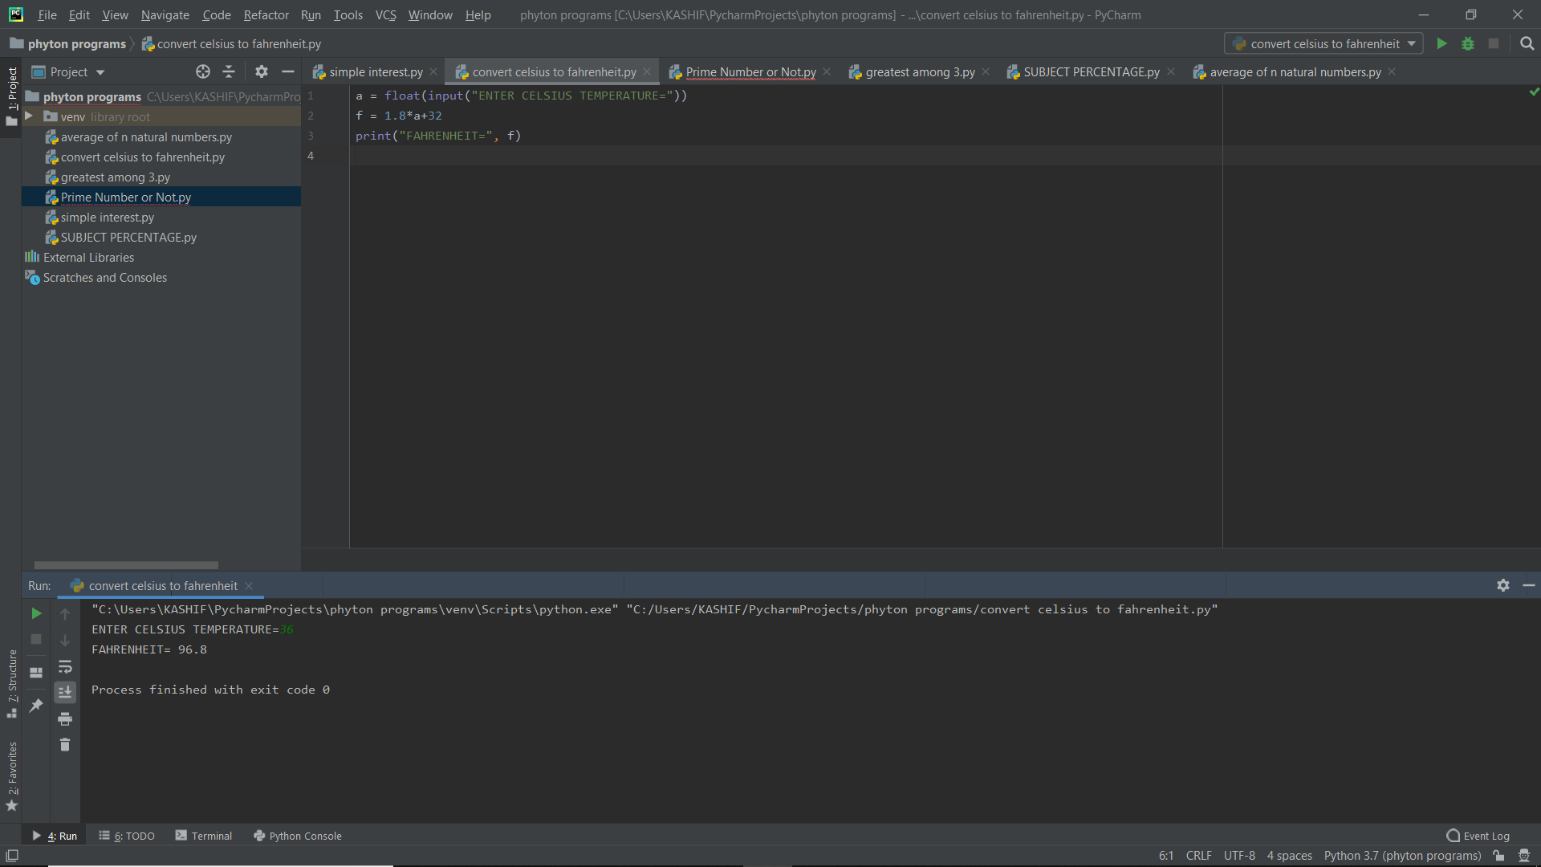

1. Python to check whether given number is prime or not?

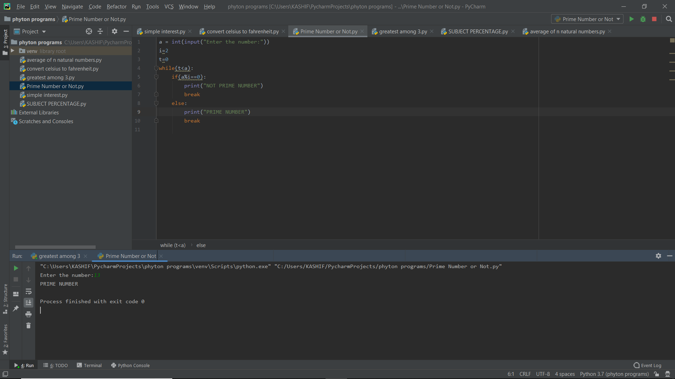

1. Python to check whether given number is Armstrong or not ?

